GUIDELINES FOR ABSTRACT PREPARATION
Ivanov I.I.¹, Petrov P.P.²
¹ S.S. Kutateladze Institute of Thermophysics SB RAS,
630090, Russia, Novosibirsk, Lavrentyev str., 1
² Novosibirsk State Technocal University,
630073, Russia, Novosibirsk, K. Marx sq., 20

The current guidelines contain the information concerning the authors’ abstracts to be published in the proceedings of 6th International conference «Heat and mass transfer and hydrodynamics in swirling flows». Abstracts which do not meet the described criteria will not appear in the conference proceedings. The deadline for the submission of abstracts and authors' information is April 17, 2017. The conference language is Russian and English.
Abstracts should be sent to the conference e-mail address indicated below. Abstracts should be prepared in MS Word (doc, not docx) and Adobe Acrobat (pdf). The files should be identical. In case of several abstracts co-authored by one author or group of authors the required documents should be provided for each abstract separately.
This document serves as a template for the abstract. We used a set of style files for MS Word 97-2003 editor prepared by organizing committee.
The length of the abstract is 1 page A4 with 20 mm margins (left, right, bottom) and 15 mm (top). The distance from the header is 12,7 mm. The text is arranges in two columns with a gap of 7 mm between. The automatic shift have to be used.

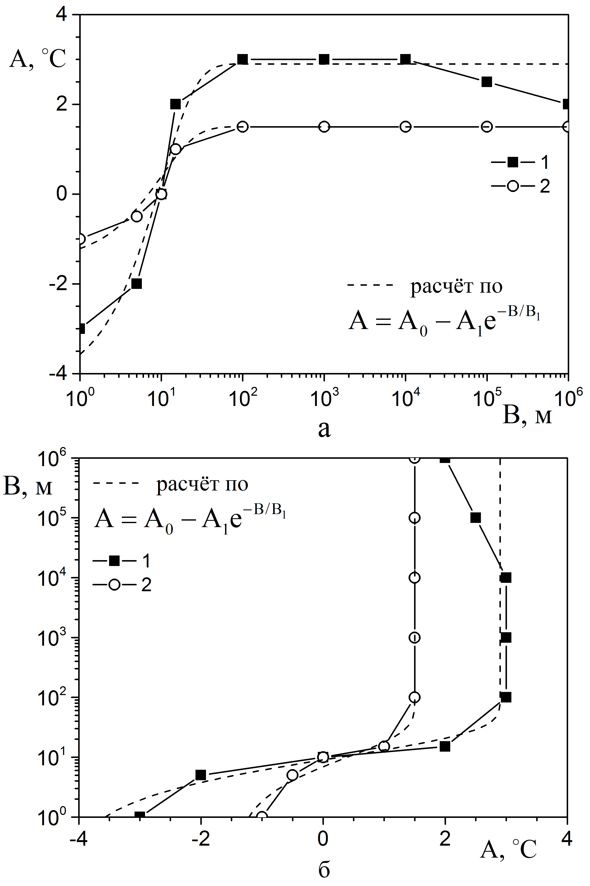
Fig. 1. Dependence parameter B from parameter A.

References:

- Nield D.A. and Bejan A. Convection in Porous Media // New York: Springer-Verlag. P. 125–176 (2005). Book.
- Surzhikov S.T. Radiation transfer within non-homogenous layer// High Temperature. 1997. V. 35. No. 3. P. 1-2. Paper.

phone.: +7 (383) 316 50 32
e-mail: swirlflows2017@yandex.ru.

