TRANSPORTATION FROM HOTELS TO THE A. GENOINO SCIENTIFIC INSTITUTE (CONFERENCE VENUE)

Hotel Lloyds Baia
The Hotel is located at 4.5 Km distance from the center of the city Cava dei Tirreni.
Taxi are available at approximately 5 EURO cost.
Bus CSTP, line n. 9 is available approximately every 15 minutes. Stop close to the Cava dei Tirreni train station and follow the same instructions shown on the map available for the Victoria Maiorino Hotel.
Hotel Pineta Castello
The Hotel is located close to the Castle, approximately 4 Km distance from the city center and is not easy to reach walking (see map).
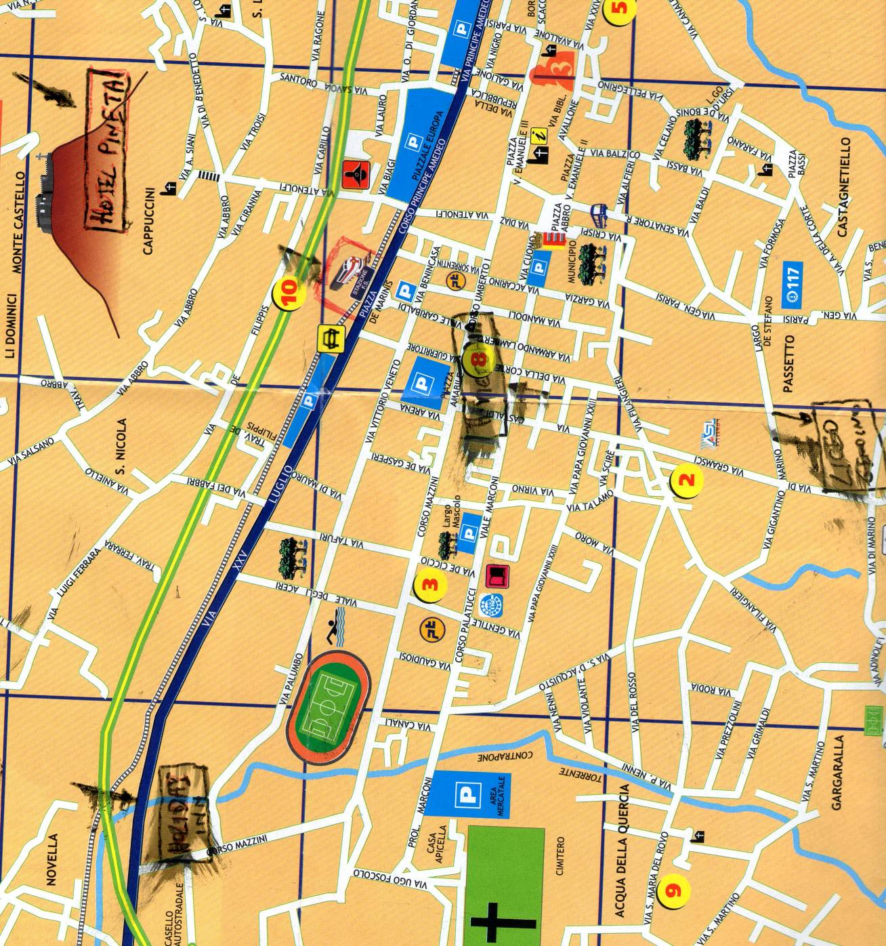
Liceo A. Genoino
Holiday Inn
Hotel Pineta
Train Station
Taxi are available at approximately 5 EURO cost.
Bus n. 64 is available (trip duration approximately 15 minutes) according to the following time schedule:
Hotel-Train Station
7,20 – 13,20 – 18,30
Train Station-Hotle
7,35 – 13,35 – 18,45
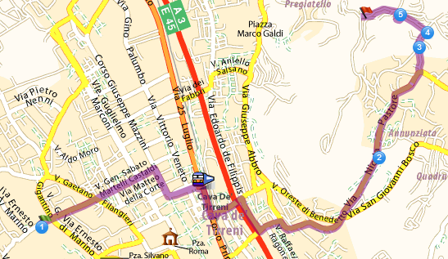
1
3
2

1 = Liceo scientifico “ A. Genoino”
2= Hotel Castello
3 = Station
Distance Km 4
Hotel Victoria – Maiorino
The Hotel is located in the city center at 5 minutes walking distance (800 meters) from the Conference Venue (see map), 100 meters distance from the train station. Only few rooms are available.
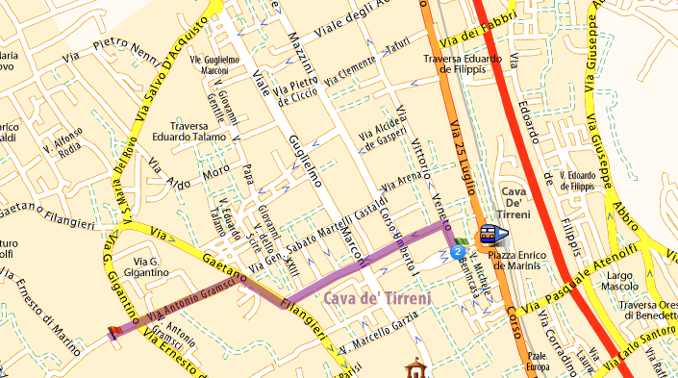
1
2
3
1 = Liceo scientifico “ A. Genoino”
2= Hotel Victoria Maiorino
3 = Station

Hotel Holiday Inn
There are many buses available from the street SS. 18 ( every 15 minutes). Stop close to the Cava dei Tirreni train station and follow the same instructions shown on the map available for the Victoria Maiorino Hotel.
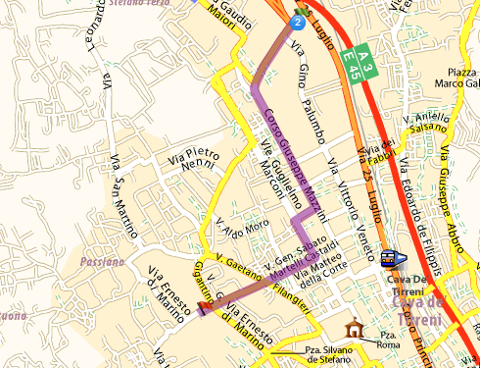
1
3
2
1 = Liceo scientifico “ A. Genoino”, 2= Hotel Holiday Inn , 3 = Station
Distance Km 1,9
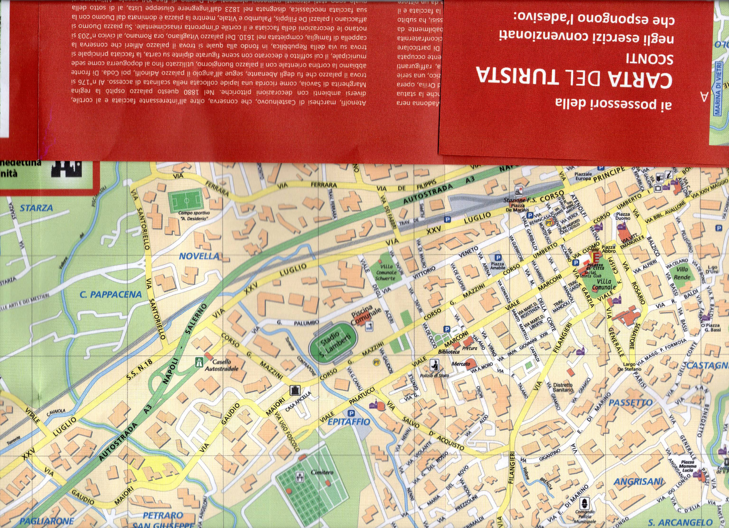

^{H}

^{L}

H= Holiday Inn Hotel ; L= Liceo scientifico “ A. Genoino “

