Gas jet deposition of diamond from high velocity gas flows

Alexey Rebrov

Kutateladse Institute of Thermophysics
Prosp. Lavrentieva 1, 630090, Novosibirsk, Russia
rebrov@itp.nsc.ru

At the moment, diamond is one of the most promising functional materials rather than a precious jewel. This material is in high demand in various fields of industry, including production of electronic devices, cutting and drilling tools, optics, high-pressure engineering, etc. If diamond is obtained by means of chemical vapor deposition (CVD), its mineral properties are retained and its extreme properties can be also used, whereas the overall cost of the material is decreased. In terms of types of activation precursor gases necessary for growth of diamond structures, the CVD technology is implemented by several different methods: activation in radio frequency and microwave plasmas, activation in the arc discharge plasma, and thermocatalytic activation on hot wires made of refractory metals (W, Mo, Ta, or Re). All these methods have certain advantages and, correspondingly, disadvantages.
The main goal of activation is to decompose the gases to active fragments. The kinetic features of the formation and transportation of particles are different in plasma and thermocatalytic methods [15] of activation. In electric arc plasmatrons, activation occurs in the electric arc column. In the case of deposition on hot wires, activation occurs due to thermocatalytic reactions. It is known that atomic hydrogen plays a key role in obtaining diamond structures by the CVD method, because it assists in methane decomposition to methyl СН3, which serves as a source of diamond growth, activates the diamond surface, prevents graphitization of the substrate surface, and saturates broken bonds on the diamond surface. In CVD methods with thermal activation on hot wires, there is a problem to ensure a sufficiently high concentration of atomic hydrogen in the H2 flow and also to prevent carbidization of activating surfaces.
The present presentation describes the results of using the CVD method with thermocatalytic activation in the case of interaction with extended heated metal surfaces. An important feature of this approach is a higher degree of dissociation of hydrogen molecules. The CVD process can be organized both under the condition of a frozen composition of the mixture after gas decomposition in the reactor and in a completely equilibrium state. The main goal of optimization of diamond-like film deposition is to identify parameters that produce the most important effects on the growth process. These are the pattern of injection of the mixture into the regions of activation and heating, the temperature of the activation surface, the gas flow intensity, the pressure in the test section, the substrate material, the methane concentration in the Н2+CH4 mixture, and the substrate temperature. A novel source of the activated gas mixture was used in the present study, which ensured a possibility of changing test parameters within wide limits.
Specific features of hydrogen dissociation in channels were numerically studied, and possibility of reaching a high degree of hydrogen dissociation at the channel exit owing to multiple collisions with the surface was demonstrated. This fact gave grounds for using a special reactor whose design allows one to combine the advantages of different activation methods, thus, expanding the parameter adjustment options.
The results of diamond structures deposition will be presented in the lecture in the range of examples.

This work was supported by Russian Scientific Foundation 15-19-00061.

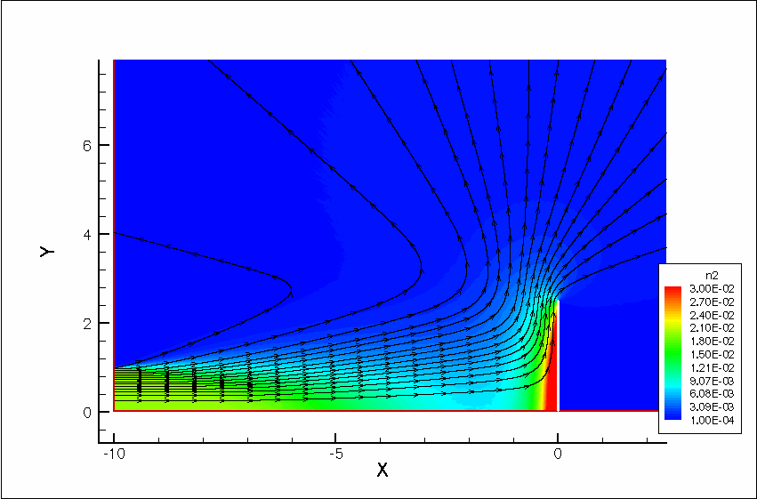
Figure 1: Conception of deposition.

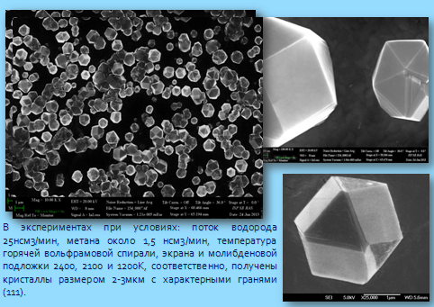

Figure 2: Example of deposition.

