Experimental determination of local heat flux during droplet evaporation in microgravity

Michael J. Gibbons*, Maxime Rouzes*, Giacomo Saccone°,Seamus O’Shaughnessy*,
Paolo Di Marco°, Anthony J. Robinson*

°DESTEC, University of Pisa, Italy; *Department of Mechanical and Manufacturing Engineering,Trinity College Dublin, Ireland
MIGIBBON@tcd.ie, g.saccone@ing.unipi.it, ROUZESM@tcd.ie, OSHAUGSE@tcd.ie, p.dimarco@ing.unipi.it, AROBINS@tcd.ie

Introduction
Evaporation of sessile drops is of significant scientific and engineering interest. It represents a common natural phenomena that is not fully understood while at the same time is used in many industrial fields, ranging from DNA mapping to evaporative spray cooling (Marchuk et al., 2015). Droplet evaporation dynamics depends on many factors, including though not limited to wettability, the evaporation flux at the interface and the triple line, the substrate temperature, external fields and thermocapillarity, and these have been researched extensively over the past decade. From a thermal transport standpoint, the process is a complex interaction of diffusion within the substrate, buoyant convection in the gas and liquid phases, contact line evaporation, vapor diffusion, evaporative cooling at the liquid-gas interface and possible Marangoni effects. The droplet evaporation process is clearly very complex and even though considerable progress has been made with regard to understanding the thermal and fluid transport processes, they are still not fully understood, in particular with regard to the conjugate heat transfer near the triple contact line (Zheng et al., 2016).
Recent works highlighted the dependency of droplet evaporation process on the working fluid, surrounding gas, and heated substrate properties (Brutin, 2015). The highest local heat transfer for an evaporating droplet occurs at the contact line (Marchuk et al., 2015). The contact line or triple line is defined as the region where the gas, liquid and solid phases intersect. It can be broken-up into four distinct regions: Micro-convection region, Intrinsic Meniscus region, Transition region, and Absorbed film region (Stephan and Hammer, 1994, Raghupathi and Kandlikar, 2016). These are depicted in Figure 1.
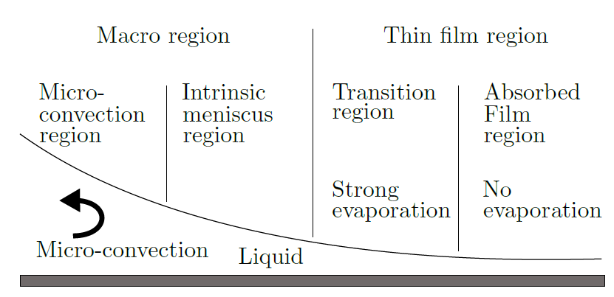
Figure 1: Droplet evaporation at the contact line, Adapted from Raghupathi and Kandlikar, 2016.
The absorbed film region is characterised by long range intermolecular forces. This disjoining pressure results in a flat liquid-gas interface of a few nanometers thick and prevents evaporation occurring in this region. The transition region is defined by growing film thickness which results in a reduction in the long range intermolecular forces. This region experiences the highest heat fluxes across the droplet as a result of the low thermal resistance due to the small film thickness. As the film thickness increases further, from the transition region into the intrinsic meniscus and micro-convection regions, so too does the thermal resistance resulting in a decrease in the local heat flux. Both the intrinsic meniscus and micro-convection regions are characterised by surface tension and inertial forces (Stephan and Hammer, 1994). Heat is transferred at the liquid-solid boundary by diffusion and advection.

The underlying physical processes occurring in droplet evaporation are investigated by measuring the local convective-evaporative heat flux beneath an evaporating droplet. Experiments were carried out both on ground under terrestrial conditions and under micro-gravity conditions in the 66th esa parabolic flight campaign, held in May 2017. Results will be presented and discussed after the experimental setup presentation.

Experimental setup
The experimental apparatus consists of two primary components; the heat transfer section, and the imaging system. These are described below and illustrated in the rig schematic in Fig 2.

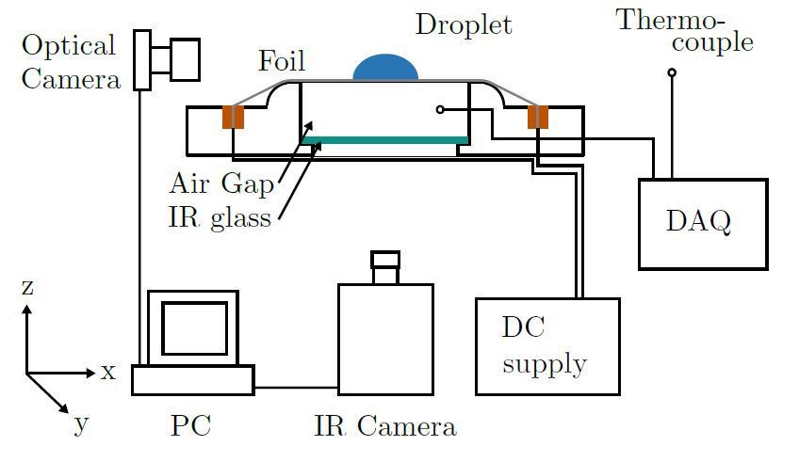
Figure 2: Schematic diagram of experimental set-up.
The thermal exchange section consists of a 25 µm thick, 0.072 x 0.035 mm² Goodfellow Stainless Steel 316 (Fe/Cr18/Ni10/Mo3) foil. The foil is clamped between two copper bus bars, with both bus bars electrically connected to a DC power supply. The copper bus bars are mounted to a polyrtheretheketone (PEEK) housing. A tensioning system is employed in order to counteract foil warping at higher wall heat fluxes. The 25 µm foil is stretched across a 0.70 x 0.40 x 0.15 m³ central PEEK. The latter serves to house a 0.040 x 0.040 x 0.003 m³ infrared (IR) transparent Zinc Selenide window. The top of this IR window is positioned 15 mm below the underside of the foil. This configuration establishes a 0.030 x 0.030 x 0.015 mm³ air cavity. During experimentation this trapped air acts as a thermal barrier, ensuring that the heat transfer by conduction on the underside of the foil is low. An exposed T-type thermocouple is used to measure the air temperature at the midpoint of the air gap cavity. The underside of the foil is exposed for direct temperature measurement by an infrared camera. It is coated with a thin layer of matt black paint of known emissivity to facilitate accurate temperature measurement. The heat transfer section is mounted on a 3D-printed PLA baseplate. The heater is fed via a DC power supply, 20 A 2 V max, computer-controlled via LabView. The current fed to the heater may be changed during the tests, in order to vary its temperature, in the range 60 °C to 90 °C. The heater power is measured by multiplying the current by the voltage drop, which is measured by means of two sense wires soldered on the two sides of the foil. A washer-shaped electrode is placed above the heater (which is grounded) to generate the required electric field. The center hole allows the insertion of the needle for droplet generation and deposition. A voltage up to 8 kV dc can be applied to it. The electrode is connected to a high voltage, high-impedance DC power supply (Spellman RM18P3000D) controlled by a manual potentiometer.
The imaging system consisted of two parts; an optical camera and a FLIR A655sc thermal imaging camera. Each camera is individually controlled by a dedicated computer. The high resolution and high frame rate InfraRed camera was used to capture the thermal footprint of the evaporating droplet. The IR camera is mounted to the aluminium profile, directly below the thermal exchange surface. The IR camera is fitted with a 50 mm lens. The full camera resolution gives a 640 x 480 pixels² field with each pixel corresponding to a width of 157 µm. After a test is completed the acquired raw data is exported in a .seq file extension and is later processed in MATLAB.
The optical images are taken at a resolution of 215 pixel/mm and are used to derive the droplet profile, which is digitized and compared with theoretical and numerical predictions. From the shape of profile it is also possible to evaluate all the forces acting on the droplet.

Results
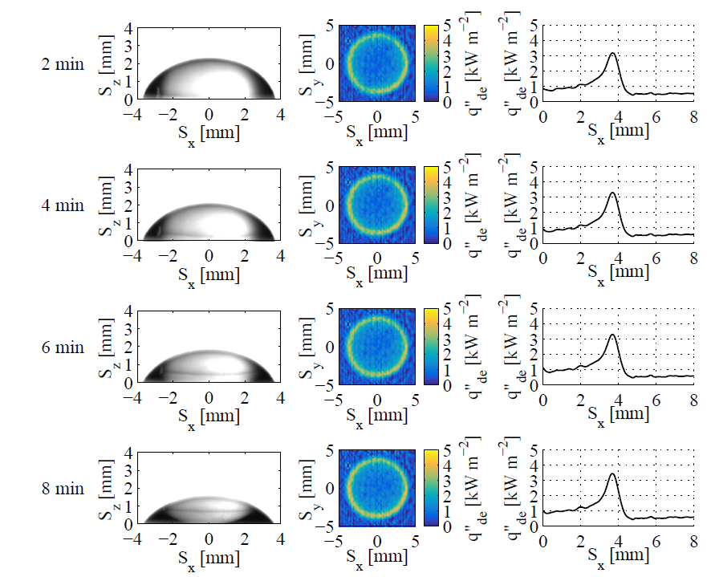
Figure 3: Wetting droplet evaporation, shape, heat flux distribution and radial heat flux profile over time in terrestrial gravity conditions.
Figure 3 shows the droplet shapes, heat flux distributions and local convective heat flux distribution over the evaporation pinned regime in terrestrial gravity conditions. From left to right column, it can be seen the droplet boundary profile, the local convective heat flux distribution and the radial convective heat flux profile. It clearly shows that the droplet follows Constant Contact Radius mode evaporation process. The radial heat flux profile highlights that the peak convective heat transfer is located at the triple line at all times. Despite an obvious droplet morphology change, the local heat flux profile remains basically the same due to pinned contact line. One can therefore conclude that a clear change in the apparent droplet contact angle yields no change in the thin film transition region due to the near constant heat flux distribution.

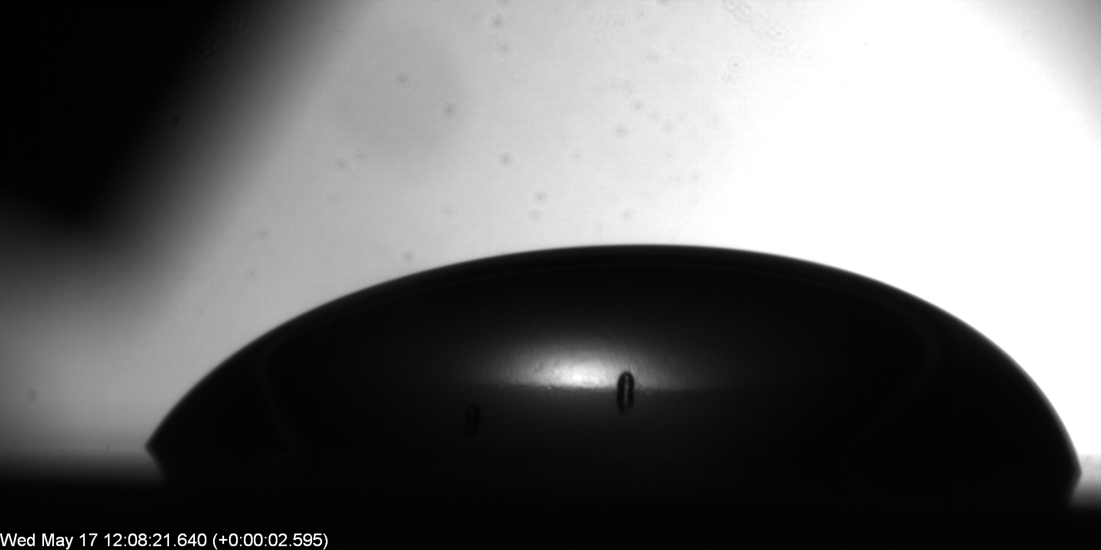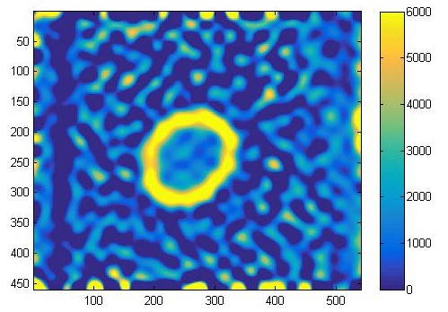
Figure 4: optical droplet images (left) and heat flux distribution (right) obtained in the 66th ESA parabolic flight campaign under terrestrial conditions.
Figure 4 shows the heat flux distribution of an evaporating droplet and the droplet shape obtained respectively from the IR and optical cameras. Those images are preliminary results from the 66th ESA parabolic flight campaign. In the latter, experiments were carried out with and without electric field under both terrestrial and micro-gravity conditions. When a sessile droplet evaporates while an electric field is applied, its shape results from the balance of surface tension, electrostatic and gravitational forces. Its evaporation rate as well as its shape is also intrinsically linked to the contact line motion. This investigation focuses on the impact of force fields (namely, a static electric field and the gravitational one) on triple line dynamics and heat transfer. Their respective contributions to the local convective heat flux in the contact line region and across the entire evaporating droplet will be presented.

References

D. Brutin, Droplet Wetting and Evaporation: From Pure to Complex Fluids, Academic Press, 2015.

P. A. Raghupathi, S. G. Kandlikar, Contact line region heat transfer mechanisms for an evaporating interface, International Journal of Heat and Mass Transfer 95 (2016) 296-306.

I. Marchuk, A. Karchevsky, A. Surtaev, O. Kabov, Heat flux at the surface of metal foil heater under evaporating sessile droplets, International Journal of Aerospace Engineering 2015.

Z. Zheng, L. Zhou, X. Du, Y. Yang, Numerical investigation on conjugate heat transfer of evaporating thin film in a sessile droplet, International Journal of Heat and Mass Transfer 101(2016) 10-19.

Stephan, P., Hammer, J. A new model for nucleate boiling heat transfer, Wärme - und Stoffübertragung, 30 (2), (1994) 119-125.

