Thermocapillary flows and their stability in pure fluids and binary mixtures

Ilya I. Ryzhkov

Institute of Computational Modelling SB RAS
Akademgorodok 50-44, 660036 Krasnoyarsk, Russia
rii@icm.krasn.ru

The dynamics of fluid systems with interfaces remains a challenging problem of modern physics. In such systems, the variation of surface tension due to thermal or compositional gradient along the interface can cause convective flows in the bulk fluid. This effect is especially important in weightlessness, where buoyancy convection is absent and thermocapillary forces often constitute the sole cause of motion. Thermocapillary flows play an important role in many natural and technological processes, such as propagation of liquid jets, motion of thin liquid films, evolution of ocean waves, etc.
Thermocapillary effect essentially affects the process of crystal growth by floating-zone method (Kuhlmann, 1999). To study the motion of melt in the full floating zone between the feed material and crystal, the so-called half-zone or liquid bridge model is often used. In this model, the fluid is placed between two rods (hot and cold), see Fig. 1. Liquid bridge has become a paradigm of a complex dynamical system and is often used for investigating the thermocapillary effect. In the liquid bridge, the surface tension gradient due to temperature variations along the free surface drives thermocapillary flow from hot to cold rod near the free surface and in the opposite direction at the central axis (Fig. 1). This flow is stationary for small temperature differences ΔT between the rods. When ΔT reaches some critical value, the instability sets in as a standing or axially running hydrothermal wave.
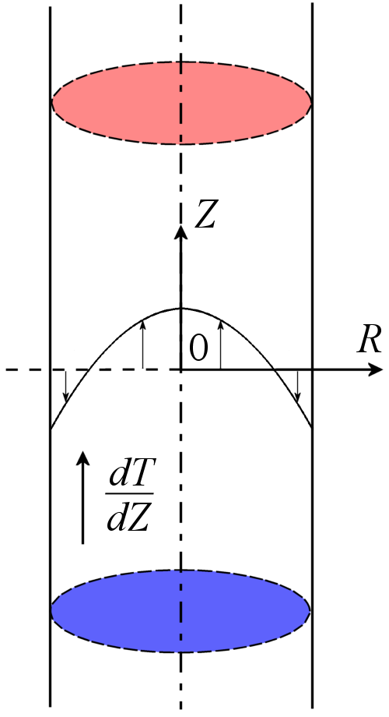
Figure 1:
Liquid column
Linear stability analysis of stationary thermocapillary flow in an infinite liquid bridge was first performed by Xu & Davis (1984). The free surface of the liquid was assumed to be non-deformable. The authors determined the critical Marangoni number Ma (which is proportional to ΔT) for the appearance of instability. It was shown that for small Prandtl numbers, the critical mode has the azimuthal wave number m=1. The instability develops in the form of two waves traveling in opposite circumferential directions along the basic flow on the interface (from hot to cold plate). For large Pr numbers, the critical mode was found to be m=0.
The linear stability analysis of steady thermocapillary flow in an infinite liquid bridge was revisited by Ryzhkov (2011). The previous results of Xu & Davis (1984) for the mode m=1 were confirmed in the range of low Prandtl number. However, for large Pr, the true stability boundary on the plane (Pr, Ma) was found to be below the previously reported one

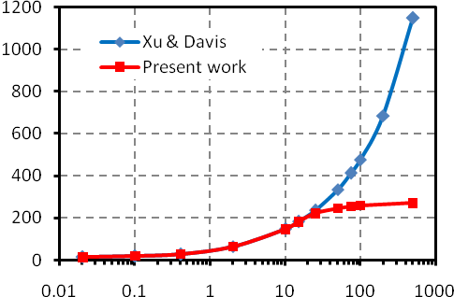
Pr
Ma
Figure 2: The dependence of critical Marangoni number on Pr.

(Fig. 2). It is associated with a new instability mode in the form of two waves traveling in opposite circumferential directions opposite to the basic flow on the interface (from cold to hot plate). A comparison with the experimental results (Schwabe 2005) showed that the corrected stability boundary was closer to the experimental values. In contrast to the work of Xu & Davis (1984), Ryzhkov (2011) showed that the mode m=1 is always critical and there is no transition to m=0 in with increasing the Prandtl number.
Thermocapillary instability in long liquid bridges was recently investigated experimentally in microgravity conditions on the International Space Station by Yano et al (2015). The experiments confirmed the existence of new instability mode predicted theoretically by Ryzhkov (2011). This mode was observed in a liquid bridge, which height was two times larger than its diameter. The liquid was 5 cSt silicon oil (Pr=67). A detailed comparison of experimental data with the results of linear stability analysis was performed.
The flows driven by interfacial tension can appear not only in liquid-gas, but also in liquid-liquid systems. The systematic studies of interfacial convection in multilayer systems of pure fluids were summarized by Nepomnyashchy et al (2006). Multilayer systems can be also formed by binary or multicomponent fluids, which exhibit phase separation when their composition or temperature are changing. In particular, phase diagrams for many binary and ternary liquids contain both one–phase and two–phase regions. If different phases of the same mixture have different densities, then this mixture forms a two–layer system in the gravity field with less dense phase in the upper layer and more dense phase in the lower layer. With increasing temperature, the interfacial tension between the phases typically decreases and becomes zero at some critical temperature. At this point, the difference between phases disappear and one-phase liquid is formed.
An example of binary fluid with phase separation provides the mixture of cyclohexane and methanol. Its phase

Figure 3: Phase diagram of cyclohexane-methanol binary mixture. Blue lines show the linear approximation
of the binodal.
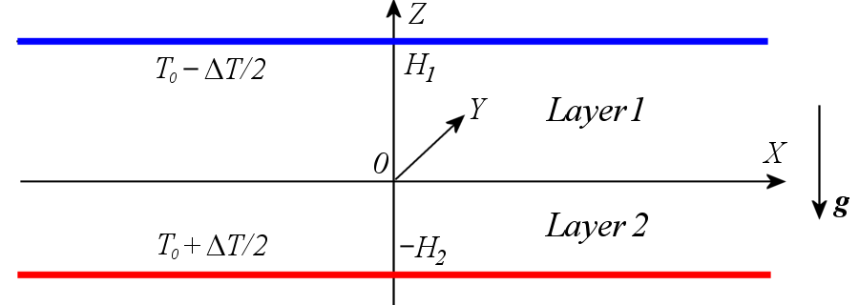

Figure 4: Geometry of the two-layer system.

diagram is shown in Fig. 3. The geometry of two-layer system, which is formed by this binary fluid in the two-phase region, is sketched in Fig. 4.
When a temperature gradient is applied to this system, the concentration gradients can form in the layers due to the thermal diffusion (or the Soret effect). This effect relates to mass transfer driven by temperature gradient. Convection in a two–layer system can be induced by buoyancy forces and surface tension forces on the interface. These forces depend on the inhomogeneities of temperature and concentrations of the mixture components. Ryzhkov and Tsarev (2015) studied the stability of mechanical equilibrium in a two–layer system formed by cyclohexane – methanol binary mixture. The temperature difference was applied to the layers by heating and cooling the opposite rigid boundaries.
The values of concentrations on the interface are determined according to the phase diagram and linearly depend on temperature, see Fig. 3. The conservation of mass for the mixture components leads to the dependence of layer thicknesses on the applied temperature difference. The linear stability of mechanical equilibrium with respect to small perturbations is investigated. The main mechanisms of instability are gravitational, thermocapillary (interfacial tension depends on temperature), and phase change (mass transfer through the interface and phase transition heat are taken into account). For the case of monotonic perturbations in the absence of gravity, Ryzhkov and Tsarev (2015) found analytical solution of amplitude equations and constructed the neutral curves describing the dependence of critical temperature difference on the wave number. The general case of monotonic and oscillatory perturbations was investigated numerically taking into account the dependence of layer thicknesses on the applied temperature difference. Different instability mechanisms were analyzed and stability maps in the parameter space were constructed.
The work is supported by the Russian Foundation for Basic Research Grant 15-01-03293.

References

Kuhlmann H.C. Thermocapillary Convection in Models of Crystal Growth. Springer, 1999.

Xu J.J. and Davis S.H. Convective thermocapillary instabilities in liquid bridges. Phys. Fluids, V. 27, 1102 (1984).

Schwabe D. Hydrothermal waves n a liquid bridge with aspect ratio near the Rayleigh limit under microgravity. Phys. Fluids, V. 17, 112104 (2005).

Ryzhkov I.I. Thermocapillary instabilities in liquid bridges revisited. Phys. Fluids, V. 23, 082103 (2011).

Yano T., Nishino K., Kawamura H., Ueno I., and Matsumoto S., Instability and associated roll structure of Marangoni convection in high Prandtl number liquid bridge with large aspect ratio. Phys. Fluids, V. 27, 024108 (2015).

Nepomnyashchy A.A., Simanovskii I.B., and Legros J.C. Interfacial convection in multilayer systems. Springer, 2006.

Ryzhkov I.I. and Tsarev S.P. Onset of convection in a two-phase binary mixture with the Soret effect in weightlessness. Phys. Fluids, V. 27, 072103 (2015).

