3D instability of liquid films and rivulets

Sergey Alekseenko, Sergey Aktershev, Aleksey Bobylev,
Vladimir Guzanov, Dmitriy Markovich and Sergey Kharlamov

Kutateladze Institute of Thermophysics, Siberian Branch of the Russian Academy of Science,
Lavrentiev Ave. 1, Novosibirsk 630090, Russia
Novosibirsk State University, Pirogova St. 2, Novosibirsk 630090, Russia

E-mail kharlamov@itp.nsc.ru

Gravity-driven film flow of a viscous liquid down a flat plane is a well known example of convectively unstable free surface flow with instabilities of different kinds leading to the appearance and interaction of surface waves with a great variety of characteristics. Specific type of film flow whereby the fluid flows in the form of many streamlets is typically called rivulet flow, whereas an individual streamlet, bounded by two contact lines, is called a rivulet. Special attention has been paid to rivulet flows because of their practical value when used in a variety of devices in power engineering and chemical technology.
This study presents the results of experimental and theoretical investigations of instabilities in the liquid film and rivulet flows. In the first part of study, the experimental results for transition from two-dimensional (2D) to three-dimensional (3D) waves in falling liquid films are presented. The method of laser induced fluorescence was used to obtain instant shapes of three dimensional waves and to investigate the regularities of formation of 3D wave patterns arising due to transverse instability of 2D waves. The regular 2D waves with prescribed frequency f were forced by harmonic modulation of liquid flow rate. Distilled water, water-glycerine solution (WGS) and water-ethanol solution (WES) were used as working fluids. The obtained results were compared to the results from the published literature on the modeling of 3D wave regimes of film flow.

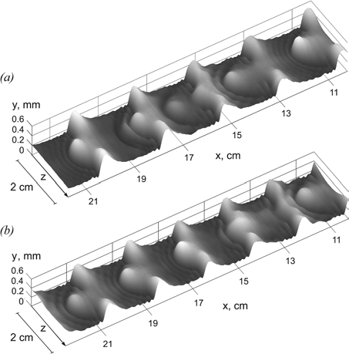
Figure 1: Scenarios of 3D wave patterns evolution. Re = 50 and L = 2 cm. (a) f = 17 Hz, oscillatory pattern. (b) f = 20 Hz, passing through pattern.

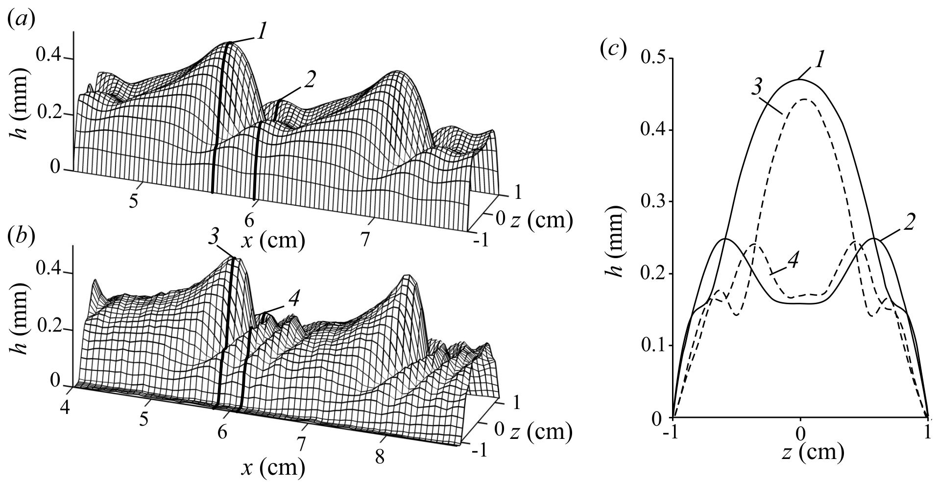
At moderate Reynolds numbers Re, two scenarios of the patterns evolution were observed (see Fig.1). For low frequencies of 2D waves excitation, the leading humps initially run away from the trailing humps. Then their amplitudes and velocities decrease so that the trailing humps which move all the time with approximately constant celerity begin to overtake the leading humps. As the trailing humps approach the leading ones, the latter begin to restore their amplitudes and the pattern structure almost repeats itself through several wave lengths. An example of such oscillatory scenario obtained previously in modeling (Dietze et al. 2014) and observed in experiments (Alekseenko et al. 2012) is shown in Fig. 1(a). For high excitation frequencies, the site between trailing humps, which was left by running downstream leading hump, is filled by another leading hump that arrives from above so that the pattern structure also almost repeats itself through several wave lengths as shown in Fig. 1(b). We will refer to such scenario as “passing through” one.
Figure 2:: Shape of the wave in the WGS rivulet compared with experimental at Re = 36, f = 23 Hz. (a) calculated 3D surface, (b) experimental 3D surface, (c) rivulet cross sections, (1, 2) calculation, (3, 4) experiment.
The second part of study is devoted to numerical simulation of 3D waves on the surface of a rivulet flowing down a vertical plate are presented. The model (Demekhin, Shkadov 1984) is used for numerical simulation of the forced waves in the rivulet. The results of the simulations are compared with the authors’ previous experimental data (Alekseenko et al. 2010). The calculations are performed only for the conditions implemented in the authors’ previous experiments. The comparison shows that the applied model adequately describes the shape of the wave surface of a rivulet, although the wave propagation velocity and wavelength are underestimated. Figure 2 demonstrates the shape of the developed waves on a WGS rivulet in comparison with experimental data for sufficiently high values of Reynolds number and forcing frequency. As it is clear from the figure, the calculation well describes the shape of the peak with capillary ripples in front of the wave, as well as rivulet profiles in different cross-sections. Significant discrepancy with the experimental data is observed in the wavelength. The calculated distance between peaks is 1.5 cm, while experiment gives 2 cm.

Conclusions
We have investigated experimentally the process of transition from 2D to 3D waves in liquid films falling down a vertical plate with a primary goal to examine to which extent the modern modeling approaches (Scheid et al. 2006, Dietze et al. 2014) adequately describe real film flows. The method of laser induced fluorescence is used to obtain instant shapes of three dimensional waves and to investigate the regularities of formation of 3D wave patterns arising due to transverse instability of 2D waves. Although many details of 3D wave patterns correspond well, there are a few significant distinctions between our experiments and modeling. In particular, during 2D-3D wave transition, we observed a strong transverse redistribution of liquid leading to the formation of rivulets on the surface of isothermal liquid film, which is a phenomenon not described previously. Our results show that forming 3D waves always resemble streak-like waves as in (Adomeit, Renz 2000) but not Λ-solitons as in (Demekhin et al. 2010).
A numerical simulation of nonlinear three-dimensional forced waves in a straight rivulet, flowing down a vertical plate, was carried out. The calculations were performed for the two liquids (WES and WGS) with different physical properties, used in experiments (Alekseenko et al. 2010). Compared with the film flow, the waves in rivulets have significant differences. In particular, the wave patterns for the cases of "small" and "large" contact wetting angles are significantly different. The calculations have shown that for WES rivulet ("large" contact wetting angle) the waves are 2D in nature, while in WGS rivulet ("small" contact wetting angle) 3D horseshoe-waves develop. Comparison of experimental data on nonlinear waves with the calculations, made for different values of the Reynolds number within a wide range of the forcing frequency leads to the following conclusions. The applied model (Demekhin, Shkadov 1984) is appropriate to describe in general the shape and amplitude of the waves on the rivulet surface at moderate Reynolds numbers. In particular, for WGS rivulet the model predicts waves of step-wise shape, which were observed in the experiments at low forcing frequencies. For moderate forcing frequencies the model predicts waves with capillary ripples in front of the wave peak. The shape of these waves is in good agreement with the experimental data. For WES rivulet the model predicts well the amplitude of developed waves and the shape of the rivulet wave surface. Besides, for WES rivulet the model predicts no capillary ripple in front of the main peak that is consistent with the experimental data.

Acknowledgements
The authors acknowledge the support by the Russian Foundation for Basic Research (projects 15-01-06702 and 15-01-04320.)

References

S. V. Alekseenko, V. V. Guzanov, D. M. Markovich, and S. M. Kharlamov, Specific features of a transition from the regular two-dimensional to three-dimensional waves on falling liquid films, Tech. Phys. Lett. Vol. 38, p. 739 (2012)

S. V. Alekseenko, A. V. Bobylev, V. V. Guzanov, D. M. Markovich, S. M. Kharlamov, Regular waves on vertically flowing rivulets at different wetting angles, Thermophys. Aeromech., Vol. 17, pp. 371-384 (2010).

E. A. Demekhin, E. N. Kalaidin, S. Kalliadasis, and S. Yu. Vlaskin, Three-dimensional localized coherent structures of surface turbulence. Model validation with experiments and further computations, Phys. Rev. E, Vol. 82, 036322 (2010).

E. A. Demekhin, E. N. Kalaidin, and A. S. Selin, Three-dimensional localized coherent structures of surface turbulence. III. Experiment and model validation, Phys. Fluids, Vol. 22, 092103 (2010).

E. A. Demekhin, V. Y. Shkadov. Three-dimensional waves in a liquid flowing down a wall, Fluid Dynamics. Vol. 19. p. 689 (1984)

G. F. Dietze, W. Rohlfs, K. Nährich, R. Kneer, and B. Scheid, Three-dimensional flow structures in laminar falling liquid films, J. Fluid Mech. Vol. 743, p. 75 (2014).

B. Scheid, C. Ruyer-Quill, and P. Manneville, Wave patterns in film flows: Modelling and three-dimensional waves,
J. Fluid Mech. Vol. 562, p. 183 (2006).

P. Adomeit and U. Renz, Hydrodynamics of three-dimensional waves in laminar falling films, Int. J. Multiphase Flow, Vol. 26, p. 1183 (2000).

