Thermophysics and Aeromechanics, 2021, Vol. 28, No. 2
DOI: 10.1134/S0869864321020128
Impact of the chimney geometry on the power output of solar chimney power plant
© H. Semai and A. Bouhdjar, 2021
H. Semai and A. Bouhdjar
Center of the Development of Renewable Energies, Alger, Algeria
E-mail: hsemai@yahoo.com
(Received October 04, 2018; revised November 20, 2019;
accepted for publication February 10, 2020)
The work studies the turbulent fluid flow under the effect of natural convection within a solar chimney power plant (SCPP). This study is carried out by numerical simulation using the Saturne code coupled to the Syrthes code. Geometric modifications were brought upon the chimney outlet. Divergent shape with different exit sections was set at the tower outlet. The study is undertaken for two types of solar chimney power plant. In the first configuration, only soil below the collector is considered as a storage system. In the second one, the storage system is composed of the soil and a 10 cm thick tub filled with water, covering the entire surface of the collector. The boundary conditions will be defined according to meteorological data, for a typical day available on the site of Adrar, Algeria. The results allow us to focus on the storage system influence on the SCPP performance and their operation duration after sunset and to determine the geometric modification effect on the plant energy efficiency.
Keywords: turbulent flow, natural convection, heat transfer, solar chimney power plant.

Introduction
Through various techniques, solar radiation can be converted into another form of energy useful for human activity, notably heat and electricity. To capture directly some of this energy, processes have been developed and are constantly being improved. In this paper, we study the processes used for electricity production from solar radiation, in particular, solar chimney power plants (SCPP). The SCPP is a concept designed to produce electricity overwhelmingly and at low cost, without the use of fossil fuel and with no greenhouse gases emission.
The SCPP can operate continuously by using direct and diffuse solar radiation during the day. Even under cloudy sky, diffuse radiation can be exploited by the SCPP for power generation. The basic idea is that electricity could be produced from a hybrid solar-wind system consisting of three parts: a collector, aero-generators, and a chimney. Their combination to produce electricity was already described in 1931[1].
The air is heated by the sunrays under the transparent cover (plastic or glass) of the col-lector, and then flows upwardly along an itinerary constituted by the collector and the chimney. The transparent cover and the floor below the cover make up the solar collector. A vertical chimney is positioned at the center of the collector with an opening at its base, from which the air coming out of the collector will flow up. The junction between the transparent cover and the base of the chimney is sealed. Its operating principle is based on the fact that hot air is lighter than cold air and so it arises. The hot air is produced by the greenhouse effect in the collector, which can spread horizontally over several meters on the surface of the ground.
The collector height under the cover may be increased in the chimney direction in order to deflect the air movement in vertical movement with minimal loss, due to friction [2–7]. As it may decrease in order to decrease the cross section, since the fluid flow remains constant, increase the fluid velocity at the chimney inlet [8].
The tower (chimney) converts the heat flow produced by the collector into kinetic energy (convection current) and potential energy (pressure drop in the turbine). Thus the difference in air density caused by the temperature rise in the collector acts as a driving force. The airflow allows the aero-generators set at the chimney entrance to produce electricity.
The SCPP remains operational for long periods, because the soil has the capacity to store the heat received during the day and to release it according to the soil-air temperature gradient and the heat exchange coefficients.
To increase the storage capacity, it was proposed in [9] to fix black tubes filled with water side by side on the ground surface below the collector cover. The tubes will be filled once and remain closed to avoid the evaporation phenomenon. In 1976, two German engineers Jorg Schlaich & Rudolf Bergermann originally proposed the idea of the SCPP [10]. In 1979, they built the first prototype with a maximum power of 50 kW in Manzanares, Spain. The SCPP operated from 1982 until 1989. Tests had shown that the installation worked reliably and that the concept was technically viable [11, 12]. Energy balance, design criteria, and cost analysis were discussed in the work [11]. Since then, many studies have been carried out theoretically and numerically. The authors of [3] studied the influence of atmospheric crossflow and the fluid flow inside a solar updraft tower (SUT) by assuming SUT inflow as a compressible flow.
The impact of a strong ambient crosswind on the system output power through the collector inlet and chimney outlet was investigated in [13] where the numerical simulation results revealed that ambient crosswind had influence on the performance of the plant in two ways. On the one hand, when the ambient crosswind is comparably weak, it will deteriorate the flow field and reduce the output power of the SUPPS. On the other hand, it may even increase the mass flow rate and output power if the crosswind is strong enough.
The effects of various parameters on the maximum potential power output of the solar updraft tower power plant (entrance collector gap, roof collector inclination, and tower diameter and height) were studied in the work [14].
The authors of [15] investigated, through CFD technique, the changes in flow properties caused by the variations of flow area. They found that the roof collector sloping affected the plant performance. The divergent-top chimney leads to augmentation in kinetic energy at the chimney base significantly. A suitable combination between the roof collector sloping and the divergent chimney top can produce as much power as hundreds of conventional solar chimney power plants. The authors of [16] realized a pilot sloped solar updraft power plant in the south campus at Damascus University, Syria. The experiment showed that any change in solar radiation and ambient temperature had a straight impact on the difference between the air temperature in the collector outlet and the ambient.
The impact of the geometry of guide walls (GWs) on the power output of solar chimney power plant was studied in [17]. A reduction in the mass flow rate area appeared after adding a guide wall in the system. The driving force and the velocity, however, showed a significant increase along the increasing altitude of GWs.
The authors of [18] presented a concept of extracting power from natural valley–mountain anabatic wind aided by a SUPP collector. In this case, the solar collector is built on the upper mountain slope in order to use both the heat from the solar radiation received by the collector and the extra heat from the solar radiation received by the lower bare mountain.
The effect of the ambient crosswind through chimney outlet and collector inlet independently on the performance of solar updraft power plant was studied in [19].
A numerical simulation of the solar updraft power plant (SUPP) with a circularly blockage wall set a few meters away from the collector inlet in order to overcome the negative impact of strong ambient crosswind on SUPP performance was presented in the work [20].
The authors of [21] used a heat transfer model to compare the performance of a conventional solar chimney power plant (CSCPP) and two sloped solar chimney power plants (SSCPPs) with the collector oriented at 30°and 60°, respectively. The authors of [22] developed three SUPP numerical models to explore the impact of ambient crosswind on large-scale SUPPs. In the work [23], a computational and experimental study on solar chimney power plants (SCPP) was performed to study and improve the flow characteristics inside the SCPP. The inlet collector opening, the outlet collector height, the outlet collector diameter, the divergence chimney angle, inlet chimney opening, and the diameter of the chimney were varied and optimum values that give the highest power were deduced.
Theoretical and experimental studies have been realized on the solar chimney power plants whose main objectives are summarized in the optimization of the SCPP’s efficiency, the mastery of the phenomena occurring within (heat transfer, radiation, and thermal storage). The influence of physical parameters such as the height and diameter of the tower, collector size, and the weather conditions (solar radiation and ambient temperature) on the flow were considered.
This paper aims at improving the SCPP efficiency according to a new configuration on the chimney geometry. Since the divergent chimney leads to augmentation in kinetic energy at the chimney base significantly [15, 24] and the construction of a divergent chimney tower all along its height is a rather delicate task compared to a chimney tower with a constant diameter. This leads us to consider a chimney tower of a constant diameter except at its exit where it will be diverging over a height of 2 m only. An optimization is to be looked for considering different opening angles.
Two cases are taken into consideration. In the first one, we will consider the ground located under the collector as the thermal storage system. In the second case, the storage system is made of the ground and tubes filled with water covering the whole area under the transparent cover.

Physical model of the plant
Fig. 1. Geometry model
of the Solar Chimney Power Plant.
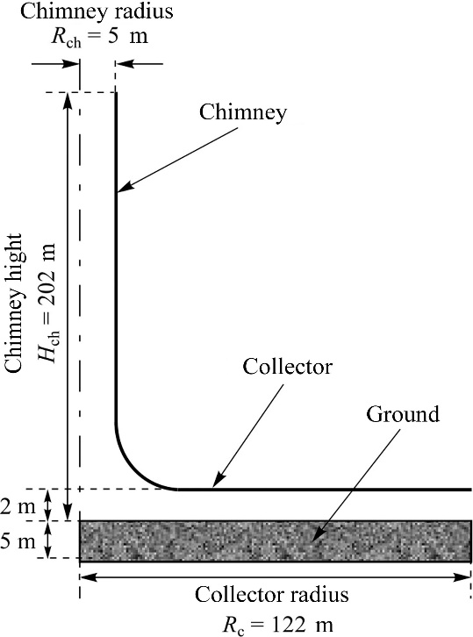
In this paper, the model of our chimney is similar to that of Manzanarés, in which we have a tower of 200 m height and 10 m in diameter and 244 m for collector diameter and a gap of 2 m between the cover and the ground surface. However, a height extension of 2 m will be added at the chimney exit, having divergent form for different sections, which gives us a tower of 202 m height (Fig. 1). These dimensions are applied for both models of the plants, a model made of the ground part only as storage system, SCPP1 and a second one equipped with an extra media storage system, SCPP2. The different sections at the exit of the chimney (different opening angles) are illustrated, according to the model considered, in Table.
Table
Configurations for SCPP considered for the study

Designation | Description
SCPP1 | The storage system is made basically of the ground  and straight chimney outlet opening (α = 0°)
SCPP1 (α = 10°) | The storage system is made basically of the ground  and divergent chimney outlet opening (α = 10°)
SCPP1 (α = 20°) | The storage system is made basically of the ground  and divergent chimney outlet opening (α = 20°)
SCPP1 (α = 30°) | The storage system is made basically of the ground  and divergent chimney outlet opening (α = 30°)
SCPP1 (α = 40°) | The storage system is made basically of the ground  and divergent chimney outlet opening (α = 40°)
SCPP2 | The storage system is made of the ground  and water tub, and straight chimney outlet opening (α = 0°)
SCPP2 (α = 10°) | The storage system is made of the ground  and water tub, and divergent chimney outlet opening (α = 10°)
SCPP2 (α = 20°) | The storage system is made of the ground  and water tub, and divergent chimney outlet opening (α = 20°)
SCPP2 (α = 30°) | The storage system is made of the ground  and water tub, and divergent chimney outlet opening (α = 30°)
SCPP2 (α = 40°) | The storage system is made of the ground  and water tub, and divergent chimney outlet opening (α = 40°)

2. Mathematical model and boundary conditions
2.1. Governing equations
A simplified calculation of a Rayleigh number defined as follows shows that the flow regime in the SCPP can be considered turbulent in the whole system except at the inlet of the collector [4].
(1)
where T_{h} and T_{c} are the maximum and minimum temperature of the system, respectively, g, β, D_{h}, α, and ν are the gravitational acceleration, thermal expansion coefficient, hydraulic diameter, thermal diffusivity, and kinematic viscosity, respectively.
Boussinesq’s approximation is applied to account for the air density variation. The conservative basic equations (mass, momentum, and energy) in addition to k-ε model used for turbulent flows are given by
(2)
(3)
(4)
(5)
(6)
where P, ρ, λ , ϕ, μ, and f_{i} — represent mean pressure, the density, thermal conductivity, energy dissipation, dynamic viscosity, and volume forces, respectively. G_{k} — represents the generation of turbulence kinetic energy due to the mean velocity gradients defined as: G_{k} = = G_{b} is the generation of turbulence due to buoyancy, S_{k} is the additional source terms for k, S_{ε} is the additional source terms for ε, and β is the thermal expansion coefficient: β ≈ 1/T$.$
The values of different model constants [25] are C_{μ} = 0.09, C_{1ε} = 1.44, C_{2ε} = 1.92, σ_{k} = 1, and σ_{ε} = 1.31, σ_{k} and σ_{ε} represent the turbulent Prandtl numbers for turbulence kinetic energy k and dissipation rate ε, respectively. The turbulent viscosity is modelled as where C_{μ} denotes an empirical constant,
The electrical power generated by the fluid flow via the conversion systems is calculated by the following relationship [13];
(7)
where η, H_{ch} , c_{p}, T∞, A_{coll}, and I_{s} are the SCPP efficiency, the chimney height, the specific heat capacity, the ambient temperature, the collector area, and the solar radiation, respectively.
2.2. Boundary conditions
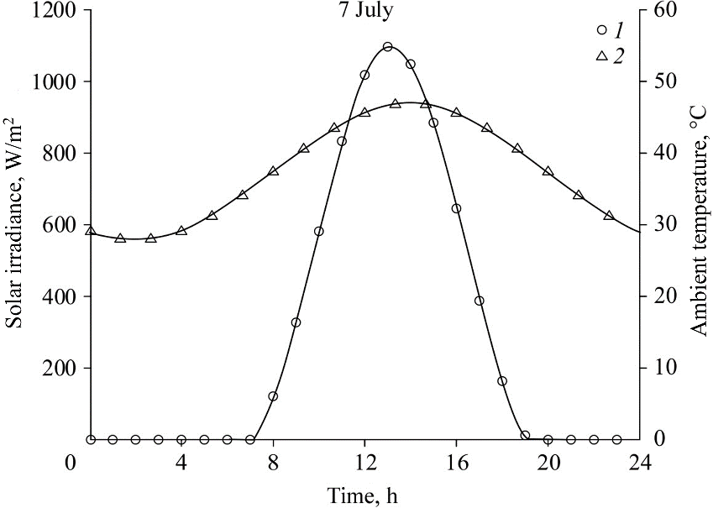

Fig. 2. Solar irradiance (1) and ambient temperature (2) versus time
for July month.
The boundaries conditions are defined from the weather conditions relative to the site of Adrar (south-western region of Algeria), solar irradiance as heat source and ambient temperature as inlet temperature [26], taken on a typical day (Fig. 2).
The relative static pressure of the collector inlet is zero, and the temperature can be the environment temperature:
(8)
The boundary condition for the bottom of the energy storage layer can be selected as a constant temperature condition as the temperature at this place varies only slightly. The soil temperature at a depth of 5 m is assumed constant, and it takes a value of 300 K. The ground heat transfer coefficient is given by
(9)
where t is the time from midnight. The thermal penetration coefficient is given by The collector cover is made of a transparent material with an average transmissivity coefficient τ = 0.64.
An adiabatic wall and non-slip conditions is considered for the chimney wall:
∂T/∂x = 0, u = 0, v = 0. (10)
In storage water, only heat conduction has been taken into account due to the small thickness of the water layer (0.10 m) as well as its confinement in a closed area (the soil surface below and the transparent wall as a cover).

3. Numerical method and validation
The Saturne CFD code is designed to solve the Navier–Stokes equations. The Saturne code is a parallel code with Message Passing Interface (MPI), which is based on a Co-localized finite volume discretization on a structured or unstructured mesh. Time discretization is based on a predictor-corrector scheme for Navier–Stokes equations. We are interested in solving the system of one-phase, unsteady, incompressible or weakly expandable three-dimensional Navier–Stokes equations based on a temporal discretization of the implicit Euler-type 1 or Crank–Nicolson order 2 and on spatial discretization by Co-localized finite volumes. This program computes, at a given time step, the speed and pressure variables of this problem by proceeding in two steps resulting from a decomposition of the operators (fractional step method).
The Syrthes code is a general-purpose thermal software for the numerical resolution of conduction and radiation in a transparent medium. It is a free code (open-source), powerful for parallel calculations. It can be coupled with many other software for modeling multi physical problems. Syrthes allows to apprehend different types of problems in thermal conduction, thermal radiation, and coupled mass and temperature transfers as it is used in many fields. The Syrthes code is a solid thermal module that is as decoupled as possible. The fluid and solid domains are meshed completely independently. The only constraint is to try to approach as best as possible the common interface between fluid and solid. The resolution is also decoupled, which makes it possible to make the best use of the numerical methods in each field. The probability of introducing errors into the fluid code is also minimized. Syrthes uses the finite element technique to solve the general equation of heat (11), where all properties can be time, space or temperature dependent.
(11)
here T is the temperature, t is the time, Φ_{v} is the volume source term, λ is the thermal conductivity of the medium (is a tensor when a medium is anisotropic). The thermal coupling between the two codes is explicit and is performed at each time step.
Let T_{w} be the temperature of the solid at the node belonging to the interface between the fluid and the solid, T_{f} the temperature of the fluid at the center of the cell situated at the level of the fluid adjacent to the wall. At instant t, Syrthes sends to Saturne the value of . The Sa-turne code then calculates the local heat exchange coefficient (coherent with the temperature difference) and sends the information back to Syrthes. Using and the Saturne code proceeds to another time step and calculates the value of . In parallel, with the values of and Syrthes updates the temperature of the solid and calculates and so on.
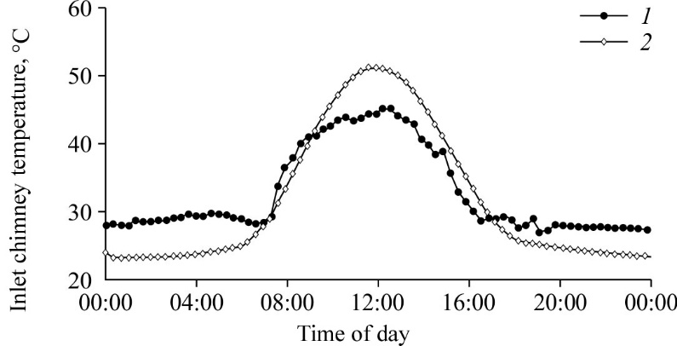

Fig. 3. Validation of the present code with the numerical results
of the work [12] for the inlet chimney temperature
(at the wind turbine inlet) with respect to time.
1 — experimental data [12], 2 — present study results.
To validate the numerical code, we performed a numerical study using the Manzanares prototype data used by the validation reference work [12]. As shown in Figs. 3, 4, and 5, we can conclude that the numerical model can be considered valid because of the successful comparison with experimental data obtained in the Manzanares pilot plant.

4. Results and interpretation
A simulation of a solar chimney power plant was carried out with the Saturne CFD Code coupled to Syrthes Code. The periodicity of the simulation is for a typical day of July. Thus, the boundary conditions considered depend on the meteorological data as defined previously.
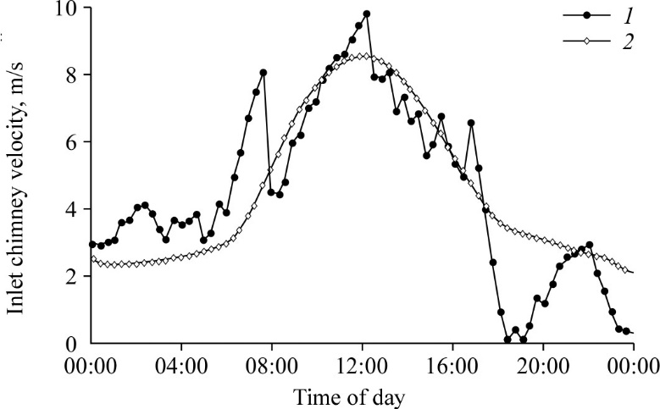

Fig. 4. Validation of the present code with the numerical
results of the work [12] for the inlet chimney velocity
(at the wind turbine inlet) with respect to time.
See notations in Fig. 3.
The results presented in Figs 6 to 8 allow us to highlight the influence of the two storage systems considered in this study. Knowing that the first storage system is composed only of the soil part (SCPP1) and the second consists, in addition to the ground part, a 10 cm thick tub filled with water, covering the entire surface of the collector.
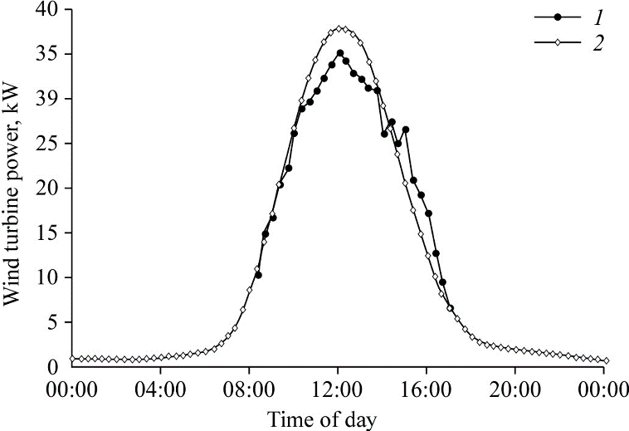

Fig. 5. Validation of the present code with the numerical results
of the work [12] for the power delivered by the wind turbine
with respect to time.
See notations in Fig. 3.
Figure 6 shows the daily evolution of the average fluid velocity where it evolves in a regular manner throughout the day. The velocity variation goes the same way as solar radiation goes. The maximum velocity values are obtained at the plant, which have only soil as storage media (SCPP1) during the daytime period. On the other hand, during the nighttime the maximum velocity values are obtained at the plant, which is equipped with an additional storage system (SCPP2).
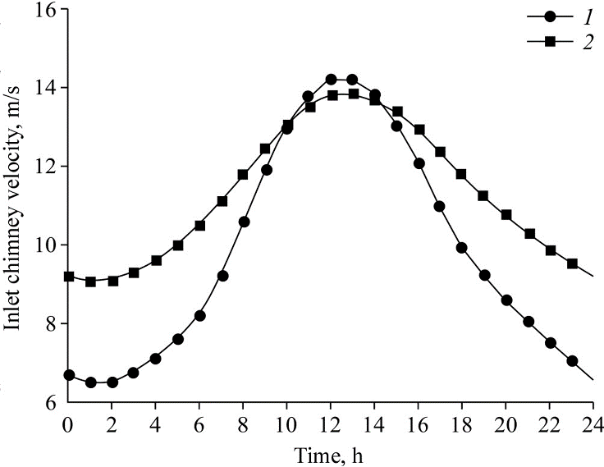

Fig. 6. Mean flow velocity at the chimney entrance.
The flow velocity value for 1 — SCPP1 and 2 — SCPP2.
However, the same observation that can be made for the power delivered by the fluid flow (Fig. 7) in which, on a day basis, the delivered power is significantly better at SCPP2, because the developed storage system allows the plant to remain operational for a long time after sunset. This allows improving the installation efficiency as shown in Fig. 8 calculated according to the following relationship [27]:
(12)
However, the following figures show the results obtained according to the modifications made on the solar chimney power plant for the case without extra storage media. The results will be compared to those given by the system with a standard configuration, namely SCPP1. The modi-fication consists of installing an extension of 2 m in length, at the exit of the chimney having a divergent shape with variable exit sections. The different exit sections are materialized by an opening angle and mentioned in Table.
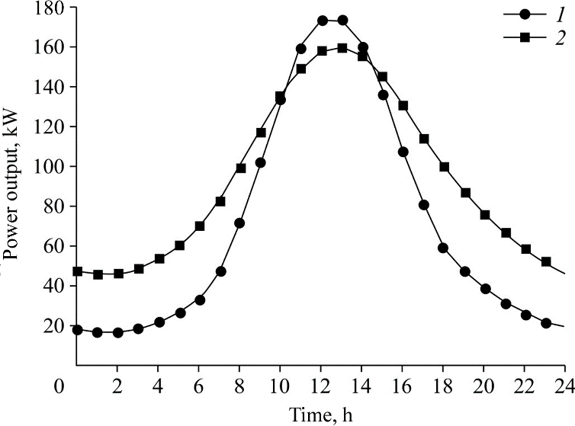

Fig. 7. Daily power production.
See notations in Fig. 6.
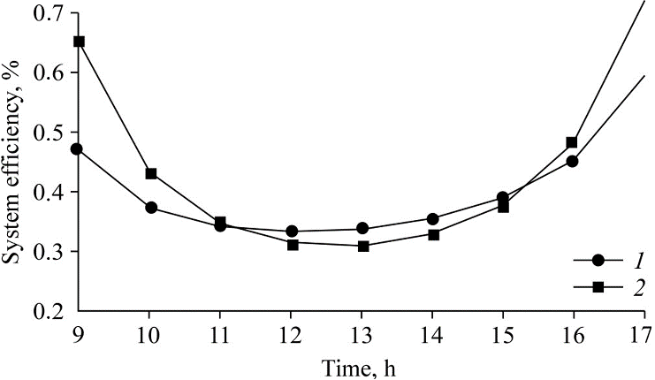

Fig. 8. Instantaneous efficiency.
See notations in Fig. 6.
Figure 9 presents the average velocity of the fluid flow at the entrance of the chimney for the case without additional storage, i.e., SCPP1. As it appears, the velocity increases regularly to a maximum then decreases to a minimum all along the day, following solar radiation. The maximum velocities are given by SCPP1, which have a divergent chimney outlet with an opening angle of 10° and 20°. On the other hand, minimum velocity is given by SCPP1 having a divergent chimney outlet with an opening angle of 40°. The increase of the velocity in the case where α = 10° and 20° can be explained as follows.
The decrease of the air density, due to the temperature rise in the collector, allows the air to rise through the chimney. The hot air column present throughout the structure is connected with the ambient outside environment by the collector at the entrance and by the chimney at the outlet. The weight of this column of air, which is lighter than that normally occupied by the ambient air, causes an elevation of this column of hot air (drawing effect). Indeed, the hot air inside the chimney is pushed towards the ambient environment at the chimney exit, and consequently, an air draft is made at the collector entrance.
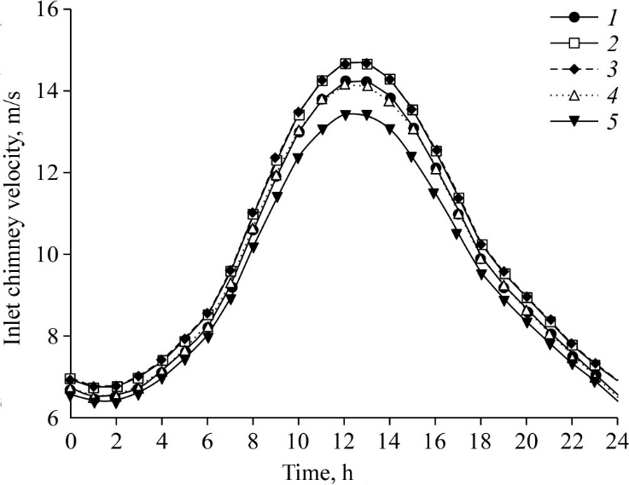

Fig. 9. Mean flow velocity for configurations SCPP1 without extra heat storage.
The power plant with the chimney in the absence of the opening angle (1)
and with opening angles α = 10° (2), 20° (3), 30° (4), and 40° (5).
The divergent shape of the duct at the chimney exit with a suitable opening angle, which is in our case is set between 10 and 20°, slightly accentuates the expansion of the hot fluid outward, which has a lighter density than the ambient air. This increases the flow velocity at the chimney outlet and consequently the flow rate, the effect of the draft and the maximum flow velocity at the chimney entrance, the appropriate place for the location of the turbines.
In the case of the use of extra water tub storage, we notice that part of solar radiation is stored in the water bed. Consequently, less energy is used to heat the air flow during daytime. Air velocities are smaller during the day compared to SCPP1 at the same moment and higher during nighttime following the absorbed heat given back by the storage system.
As expected, the electrical power production increases with the increase of solar irradiation in all configurations (Fig. 10).
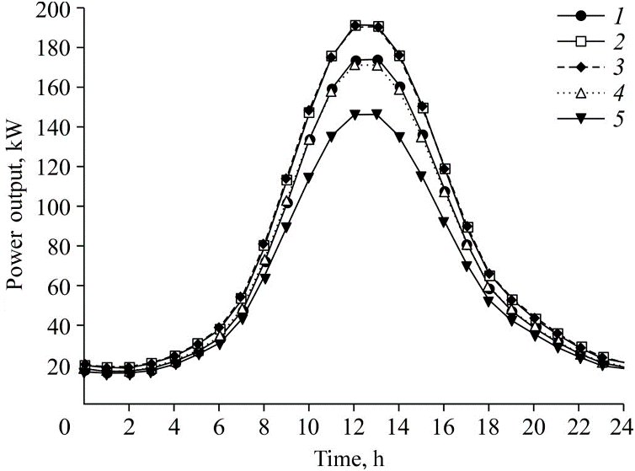

Fig. 10. Daily power production for configurations without extra heat storage.
See notations in Fig. 9.
The highest power is generated by installations having a divergent chimney outlet with an opening angle of 10° and 20°. Similarly, to the velocities, minimum power is given up by configuration having an opening angle of 40°. However, on daily basis and for the same configuration, maximum energy is given by installations equipped with extra storage media. Nevertheless, the power plants with a divergent chimney angle of 10° and 20° and equipped an extra media storage (SCPP2) generate the most electrical production. Otherwise, for a decrease of approximately of 10 % of the maximum power, we get a sensible improvement in performance during low or non-existing radiation (up to 100 % from 06H PM to 09H AM the following day).
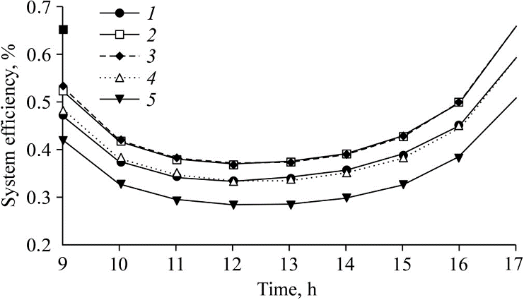

Fig. 11. Instantaneous efficiency for configurations without extra heat storage.
See notations in Fig. 9.
Figure 11 shows the instantaneous efficiency. We notice that configurations generating maximum power give up the highest efficiencies on the daily basis. Performances are also improved by the use of water tub storage in the same way i.e. configuration with divergent opening of 10° and 20°. We notice also that efficiency is improved by almost 50 % during low or non-existing radiation for a decrease of less than 20 % during daytime.

Conclusion
The paper is devoted to the numerical study of the turbulent flow under the effect of natural convection in solar chimney power plants. The purpose of the study is the evaluation of the electric power that can been generated by a solar chimney power plant implanted in the south region of Algeria and which will operate under local meteorological conditions. The analysis of the results shows that:
Electricity power production is linked to solar radiation intensity.
- Solar chimney power plant (SCPP) can operate continuously during the whole day. However, the use of an extra storage media improves electric power generated during the night period.
- Geometrically, the divergent chimney at the outlet improves also the performance of the power plant. It should be pointed out that opening angles between 10° to 20° are thermodynamically the most performing configurations.
- Combined these two modifications let the system configuration to be more optimized which has improved the performance by almost 100 % during period with low or non-existing radiation for a decreasing of less than 20 % during daytime.

Nomenclature
A — Area, m²,  b — Thermal penetration coefficient, W⋅s^{1/2}⋅K^{–1}⋅m^{–2},  c_{p}— Specific heat capacity, J⋅kg^{–1}⋅K^{–1},  D_{h} — Hydraulic diameter, m,  f — Volume forces, kg⋅m^{–2}⋅s^{–2},  g — Gravitational acceleration, m⋅s^{–2},  Gr — Grashof number,  H_{ch}— Height of chimney, m,  I_{s} — Solar radiation,  k — Turbulent kinetic energy, J⋅kg^{–1}⋅m⋅s^{–2},  L — Length scale, m, | P — Pressure, Pa,  ΔP — Pressure difference in the chimney, Pa,  P_{el} — Electric power, W,  Pr — Prandtl number,  Ra — Rayleigh number,  Re — Reynolds number,  T — Temperature, K,  ΔT — Temperature difference, K,  t — Time, s,  u, v, and w — Velocity components, m⋅s^{–1},  U — Heat transfer coefficient, W⋅m^{–2}⋅K^{–1}.
Greek symbols
λ — Thermal conductivity, W⋅m^{–1}⋅K^{–1},  α — Thermal diffusivity, m²⋅s^{–1},  ν — Kinematic viscosity, m²⋅s^{–1},  $ε$— Turbulent dissipation rate, m²⋅s^{–3}, | μ — Dynamic viscosity, kg⋅m^{–1}⋅s^{–1},  β — Thermal expansion coefficient, K^{–1},  ϕ — Energy dissipation, W,  $η$ — Efficiency.
Subscripts
b — buoyancy,  c — cold,  ch — chimney,  coll — collector,  el — electrical,  h — hot, | s — solar,  sys — system,  t — turbulent,  w — wall,  g — generation,  ∞ — environment.
References
1. J. Schlaich, R. Bergermann, W. Schiel, and G. Weinrebe, Design of commercial solar updraft tower systems – Utilization of solar induced convective flows for power generation, J. Solar Energy Engng, 2005, Vol. 127, No. 1, P. 117–124.
2. M. Ghalamchia, A. Kasaeian, and M. Ghalamchi, Experimental study of geometrical and climate effects on the performance of a small solar chimney, Renewable and Sustainable Energy Reviews, 2015, Vol. 43, P. 425–431.
3. X. Zhou, M.A. dos S. Bernardes, and R.M. Ochieng, Influence of atmospheric crossflow on solar updraft tower inflow, Energy, 2012, Vol. 42, P. 393–400.
4. A. Koonsrisuk, Mathematical modeling of sloped solar chimney power plants, Energy, 2012, Vol. 47, P. 582–589.
5. A. Koonsrisuk and T. Chitsomboon, Mathematical modeling of solar chimney power plants, Energy, 2013, Vol. 51, P. 314–322.
6. R. Sangi, M. Amidpour, and B. Hosseinizadeh, Modeling and numerical simulation of solar chimney power plants, Solar Energy, 2011, Vol. 85, P. 829–838.
7. T. Ming, W. Liu, Y. Pan, and G. Xu, Numerical analysis of flow and heat transfer characteristics in solar chimney power plants with energy storage layer, Energy Convers. and Management, 2008, Vol. 49, Iss. 10, P. 2872–2879.
8. H. Semai, A. Bouhdjar, and S. Larbi, Canopy slope effect on the performance of the solar chimney power plant, Inter. J. Green Energy, 2016, Vol. 14, Iss. 3, P. 229–238.
9. H. Kreetz, Theoretische unter suchungen und auslegungeinestempor, Diplomarbeit TU Berlin, Berlin, 1997.
10. P. Hoffmann and T. Harkin, Tomorrow’s energy: hydrogen, fuel cells, and the prospects for a cleaner planet. Massachusetts: MIT Press, 2001, 289 p.
11. W. Haaf, K. Friedrich, G. Mayr, and J. Schlaich, Solar chimneys. Part I: principle and construction of the pilot plant in Manzanares, Inter. J. Solar Energy, 1983, Vol. 2, P. 3–20.
12. W. Haaf, Solar chimneys. Part II: preliminary test results from the Manzanares plant, Inter. J. Solar Energy 2, 1984, P. 141–161.
13. T. Ming, X. Wang, R.K. de Richter, W. Liu, T. Wu, and Y. Pan, Numerical analysis on the influence of ambient crosswind on the performance of solar updraft power plant system, Renewable and Sustainable Energy Reviews, 2012, Vol. 16, Iss. 8, P. 5567–5583.
14. K.M. Shirvan, S. Mirzakhanlari, M. Mamourian, and S.A. Kalogirou, Optimization of effective parameters on solar updraft tower to achieve potential maximum power output: a sensitivity analysis and numerical simulation, Applied Energy, 2017, Vol. 195, P. 725–737.
15. A. Koonsrisuk and T. Chitsomboon, Effects of flow area changes on the potential of solar chimney power plants, Energy, 2013, Vol. 51, P. 400–406.
16. Sh. Kalash, W. Naimeh, and S. Ajib, Experimental investigation of the solar collector temperature field of a sloped solar updraft power plant prototype, Solar Energy, 2013, Vol. 98, Pt 1, P. 70–77.
17. S. Hu and D.Y.C. Leung, Impact of guide wall geometry on the power output of solar chimney power plant, Energy, 2016, Vol. 88, P. 414–421.
18. X. Zhou, Y. Xu, and Y. Huang, Novel concept of enhancing the performance of sloped solar collector by using natural anabatic winds, Inter. J. Heat and Mass Transfer, 2016, Vol. 102, P. 1356–1361.
19. W. Shena, T. Ming, Y. Ding, Y. Wu, and R.K. de Richter, Numerical analysis on an industrial-scaled solar updraft power plant system with ambient crosswind, Renewable Energy, 2014, Vol. 68, P. 662–676.
20. T. Ming, J. Gui, R.K. de Richter, Y. Pan, and G. Xu, Numerical analysis on the solar updraft power plant system with a blockage, Solar Energy, 2013, Vol. 98, Pt 1, P. 58–69.
21. F. Cao, L. Zhao, H. Li, and L. Guo, Performance analysis of conventional and sloped solar chimney power plants in China, Applied Thermal Engng, 2013, Vol. 50, P. 582–592.
22. T. Ming, Y. Wu, R.K. de Richter, W. Liu, and S.A. Sherif, Solar updraft power plant system: a brief review and a case study on a new system with radial partition walls in its collector, Renewable and Sustainable Energy Reviews, 2017, Vol. 69, P. 472–487.
23. M.R. Ahmed and S.K. Patel, Computational and experimental studies on solar chimney power plants for power generation in Pacific Island countries, Energy Convers. and Management, 2017, Vol. 149, P. 61–78.
24. S. Okada, T. Uchida, T. Karasudani, and Y. Ohya, Improvement in solar chimney power generation by using a diffuser tower, ASME J. Sol. Energy Engng, 2015, Vol. 137, P. 1–8.
25. A.K. Shukla and A. Dewan, Heat transfer and flow characteristics of turbulent slot jet impingement on plane and ribbed surfaces. Thermophysics and Aeromechanics, 2018, Vol. 25, No. 5. P. 717–734.
26. M. Capderou, Atlas solaire de l’Algérie. Algiers : University Publications Office, 1988, Vol. 1–3.
27. C. Fei, L. Zhao, and L. Guo, Simulation of a sloped solar chimney power plant in Lanzhou, Energy Convers. and Management, 2011, Vol. 52, Iss. 6, P. 2360–66.

